**Project report**

**e-commerce**

**Introduction:-**

**E-Commerce or Electronic commerce is a process of buying, selling, transferring, or exchanging products, services, and/or information via electronic networks and computers**.

“Electronic commerce, commonly written as E-Commerce, is the trading in products or services using computer networks, such as the internet. electronic commerce draws on technologies such as mobile commerce, electronic funds transfer, supply chain management, internet marketing, online transcation processing, electronic data interchange (EDI), inventory management systems, and automated data collection systems. modern electronic commerce typically uses the world wide web for at least one part of the transaction’s life cycle, although it may also use other technologies such as E-mail.

E-commerce businesses may employ some or all of the following:

* Online shopping websites for retail sales direct to consumers,
* Prociding or participating in online marketplaces, which process third-party business-to-consumer or consumer-to-consumer sales,
* Business-to-businesses buying and selling.
* Gathering and using demographic data through Web contacts and social media,
* Business-to-business electronic data interchange,
* Marketing to prospective and established customers by E-mail or fax (for example, with newsletters),
* Engaging in pretail for launching new products and services.

Pretail (also referred to as pre-retail, or pre-commerce) is a sub-category of E-commerce and online retail for introducing new products, services, and brands to market by pre-launching online, sometimes as reservations in limited quantity before release, realizations, or commercial availability. Pretail includes pre-sale commerce, pre-order retailers, marketplaces, and crowdfunding communites .

**LITERATURE SURVEY:-**

 Also, technology competencies are considered as an organization's core IT structure which encompasses hardware, software, databases and systems of external networks (Masa' deh et al., 2019). Additionally, the adoption of e-commerce has brought benefits to developed countries, but among developing countries, as reported in some studies (e.g., Vaithianathan, 2010; Das & Khan, 2016;Almajali et al., 2021),

the existing challenges have limited the adoption of e-commerce. Furthermore, citizens in developing countries appear to prefer face-to-face selling and buying because of their common practice of physically seeing and discussing the items to be purchased. ...

In developed countries, the advantages of e-commerce are yet to be comprehended by many of the businesses. In fact, in developing countries, some issues related to ecommerce have to be resolved first in order that the gains of e-commerce could be reaped (Vaithianathan, 2010; Khan & Fournier-Bonilla, 2016; Al-A'wasa, 2018). In developing countries, e-commerce allows small and medium-sized companies to increase their sales and income as e-commerce allows these companies to expand their market opportunities, not only in local markets, but also in foreign markets. ...

The increase in business transactions at international levels resulting from the use of e-commerce, and the impact of e-commerce related obstacles within the context of developing countries have been examined by a few scholars

including Vaithianathan (2010), Azizi (2013), and Bashir and Khan (2016). In their study involving developing countries, Oreku et al. (2009) reported the significant potential of e-commerce in empowering people in their efforts of resolving challenges and in forming a sustainable economy. ...

 E-commerce has become the most popular application in m revenues, and forging a rapid growth in related technology. Companies are now adopting social computing technologies that were designed for individual use (such as blogs, wikis, file sharing and social networks) to increase the effectiveness and efficiency of their operations (Turban et al, 2008).

E-commerce is an innovation in Information and Communication Technology that is changing the way marketing is being conducted globally and is a driving force of the current globalization by ensuring that marketing activities take place with minimum barrier in terms of location and time.

**THEORITICAL ANALYSIS:-**

**BLOCK DIAGRAM:-**

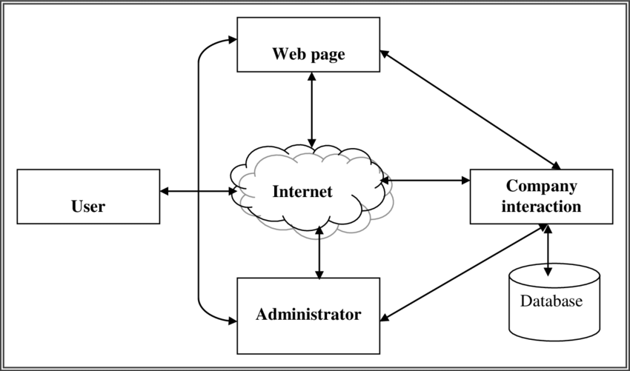

**E-commerce Requirement :**-

**Telecommunication Infrastructure Requirements** – it is entailed with bandwidth and security. Bandwidth varies from one e-commerce to another.

Two main components of security requirements for e-commerce are type of firewall and encryption/algorithm mechanism. Security requirements area crucial part of e-commerce.

**Hardware Requirement for E-commerce** - Pentium II/III based Intel server running Linux can serve hundreds of unique customers each day. Low traffic sites can be easily served from a single machine depending on the needs of the business. High traffic sites require a backup of servers which automatically takes over operations in case of failure of primary ones.

**Software Requirements for E-commerce** – Several software are available free on the internet that can be used to build e-commerce exchanges.

Ex:- Linux OS, mySQL database ,Apache web server etc.,

**Technical Skill** -A systems administrator must have a good knowledge of computer hardware, must be able to maintain and upgrade hardware including hard drive, processor and motherboard. He/she must also have the skill to install and compile Apache, MySQL and Java servlet engine.

**Financial Infrastructure** –

1. Dependable telecommunication network
2. ii) Use of integrated banking software for ack office and front office data processing
3. iii) Use of WAN and internet for banking operations
4. iv) Availability of legal infrastructure supporting online payment mechanism.
5. V) Availability of EFT Legal and Policy framework – policies that ensure legal certainty, security and consumer protection for online transactions and interactions should be enacted. These include the resolution of issues such as transactional security, electronic contract enforceability and authentication of individuals and documentation.

E-commerce software Catalogue display A catalogue is an organized list of goods & services being sold. An e-catalogue is a simple list of goods and services in HTML form that appears on a webpage on the website of an ecommerce company. Two types

(i)static catalogue -providing simple list of goods and services on offer.

(ii) dynamic catalogue -providing a detailed feature about items on sale in a database, detailed descriptions, shipment time etc.,

**Shopping Cart**

It is an electronic basket provided by E-commerce service providers to be used by net users to keep track of the products selected in the basket, compare and review them, modify it by adding new ones or removing unwanted goods before finally deciding to purchase. After the shopping is completed the customer will make the payment through online. Features or Procedures for Shopping cart

• Compare and select the goods before purchasing.

• Select the goods easily -by clicking.

• Customize the product based on the size, quantity, colour etc., before proceeding to order.

• Getting information about the offers, discounts & price.

• Specify the payment mode like credit card, debit card, cheque, online payment, payment at the time of delivery etc.,

• Mention the venue for delivery of selected goods.

• Compute shipping charges and obtain information about taxes to incur.

• Get information about delivery time.

• Have transaction confirmation message and transaction report through an email or SMS.

• Transact securely with the web seller.

• Transaction Processing It is the software that prompts processing the transaction when an online customer orders for a purchase. Transaction processing software calculates volume discounts to be allowed, sales tax.

**RESULT:-**



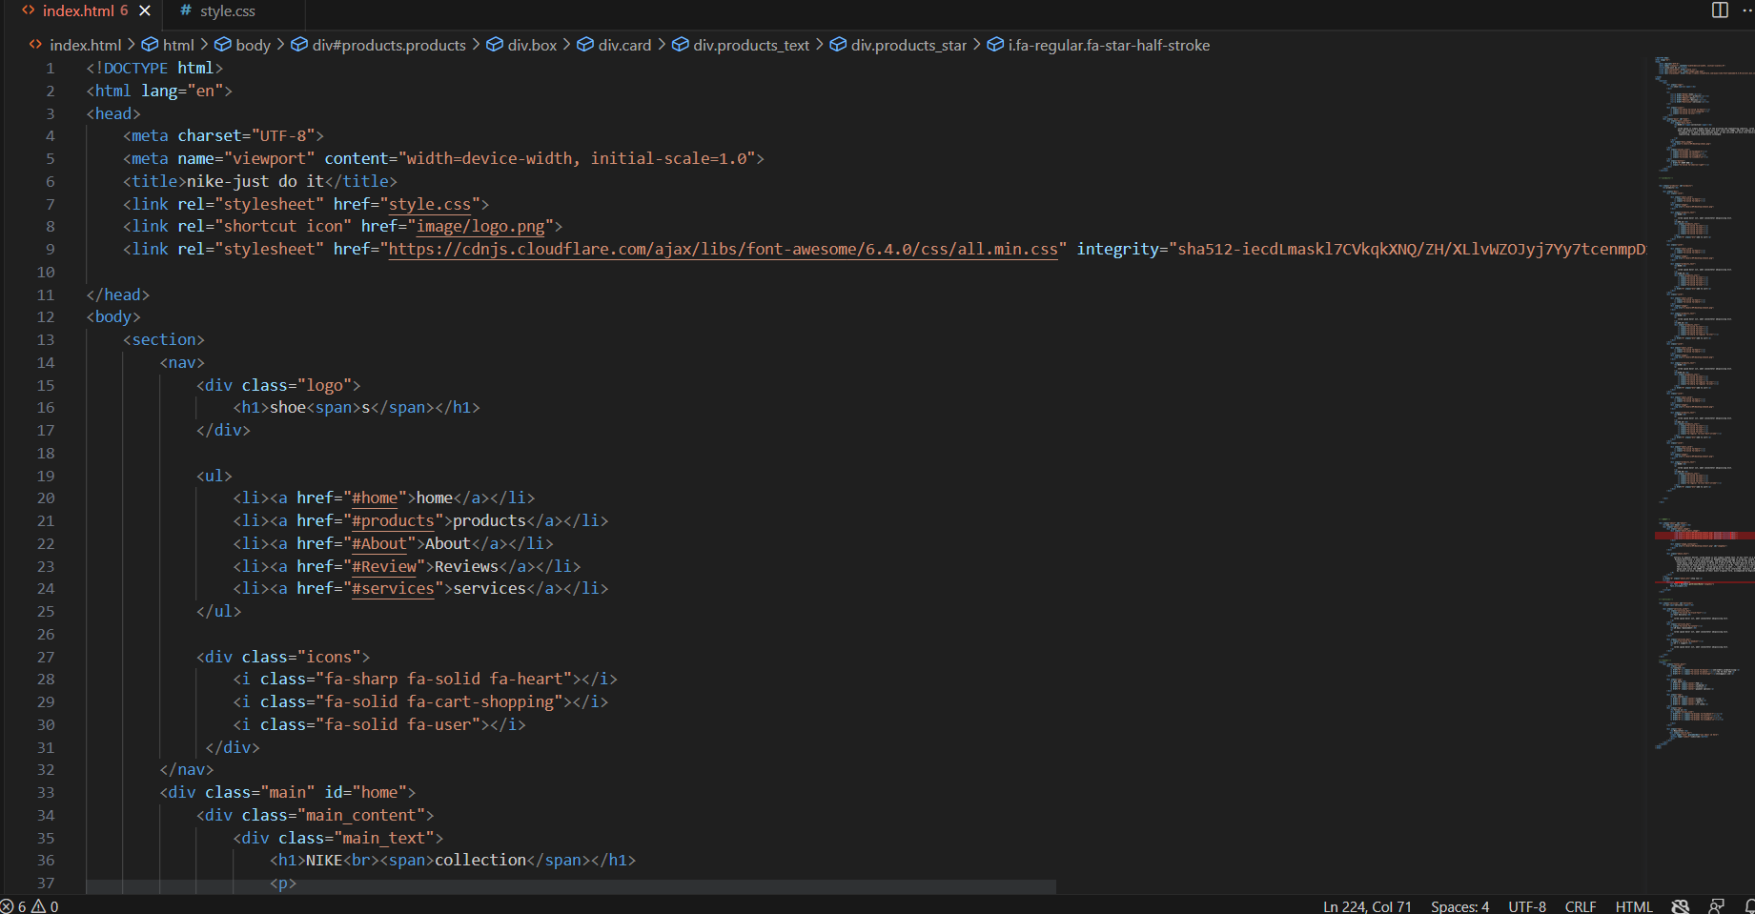

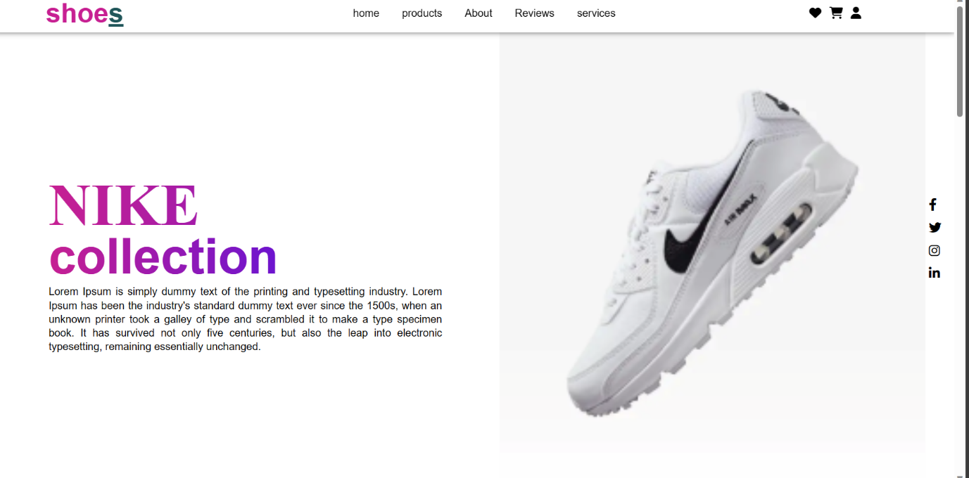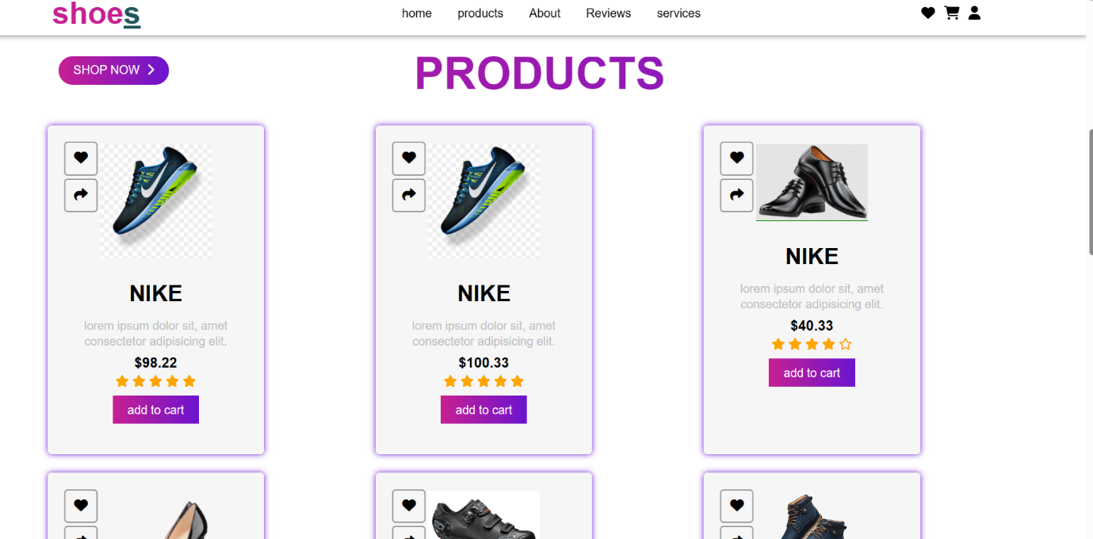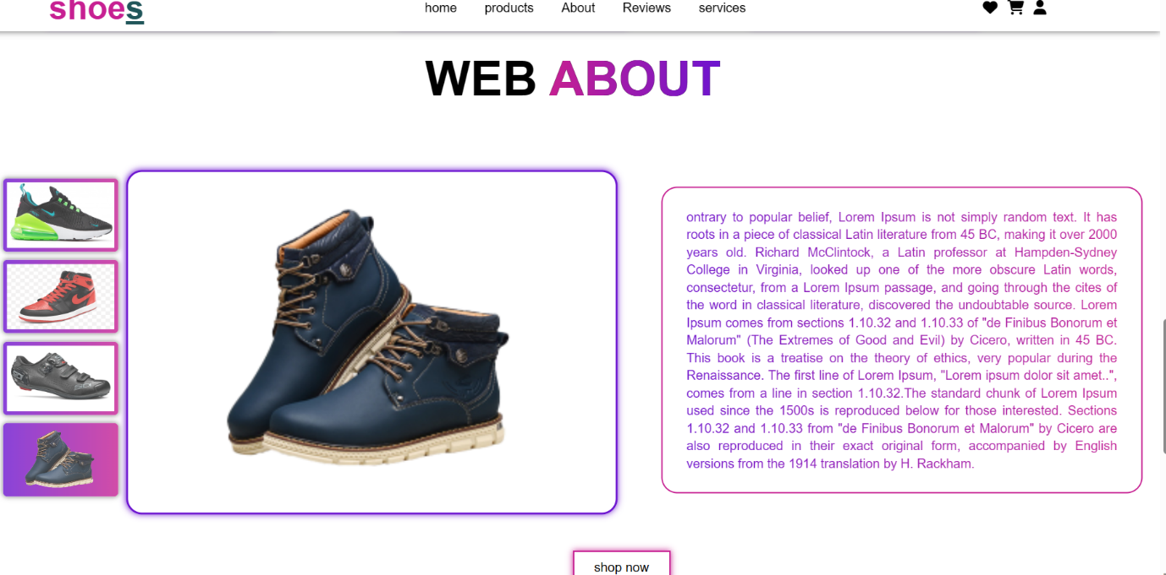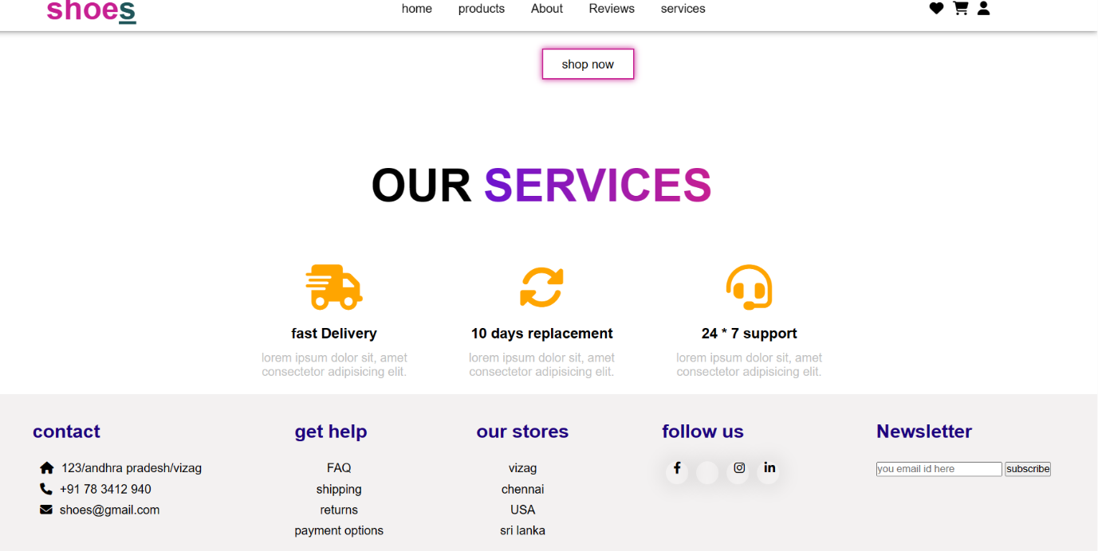

**ADVANTAGES & DISADVANTAGES:-**

(a) Enhances Convenience: Customers can make orders for goods at their own convenience and from the comfort of their homes without having to travel to the business premise. Orders are also delivered to them at their most ideal locations. It’s the best shopping option for people who are always busy.

(b) Allows for product and price comparison: Again, when making purchases , customers want to get the best deals. This business model allows for product and price comparison by consumers so that the best products are bought at the fairest prices. They can also enjoy extra benefits like discounts, coupons, items on sale and also get the best deals.

(c) Easy fund-raising for start-ups ventures: So many people have the desire to venture into business but lack sufficient funds to set up shop. Leasing a physical store can be quite expensive. E-commerce makes it easier for start -ups to do business and grow.

(d) Efficient: E-commerce has the advantage of being efficient. Resources are used efficiently since most of the business services are automated. Business owners sometimes spend a lot of resources meeting business needs and this eats into profits. E-commerce thrives on efficiency.

(e) Customer reach: It’s easier to reach many customers on the internet. Using social media links and good search engine optimization strategies, an online business can increase brand awareness and grow its customer base. It also has the advantage of being able to connect buyers and sellers from all corners of the globe.

(f) Prompt Payments: Payments are fast since online stores use electronic or mobile transactions payment methods. The mobile wallet system for merchant accounts drive up sales and increase revenue generation.

**DISADVANTAGES OF E-COMMERCE:-**

1. Poor quality products: You don’t physically see and inspect whatever you are paying for before it’s delivered . Customers, therefore, run the risk of falling victim to false marketing and buying poor products from the virtual shop.
2. Impulsive purchases: Online stores display large number of products and due to the convenience of shopping, customers an find themselves making bad financial decisions through impulsive purchases.
3. Internet Scammers: The internet is a good thing but some people have decided to use it for all the wrong reasons. Scammers have made this type of business model unattractive ffor some consumers.
4. Lack of after sales Support: As a result of lack of physical premises, customers find it hard to access after sales support. It can take up to several days before any help is accorded to a customer in need.
5. Fast changing business environment: Technology evolves so fast. Some entrepreneurs find it hard to keep up and lose a lot of business in the process. This may makes business growth unattainable.
6. Loss of Personal touch: Business is all about relationships. This business model erodes the personal touch between a customer and the business owner. Cultivating loyalty can thus be a problem since there are many such business that provide different options.
7. Delivery of goods can get delayed: It takes time before the goods ordered for are delivered. Sometimes the delivery delays and this inconveniences the customer. This is different from physical business premises where customers walk out with the products bought.

**APPLICATIONS:-**

In today’s consumers, the mobile phone is still the most favored device for  purchasing journeys even though they study on many displays and make purchases on the go: While PC usage is declining, the number of mobile transactions keeps increasing.

eCommerce apps are now crucial to the success of any business. Business owners switched from physical storefronts to digital solutions to sell online during the epidemic, which helped them improve their customer base and revenue by 55%. 53.9% of all e-commerce sales worldwide were made through mobile devices by 2021 and  ecommerce  application developed on many technology it could be on [android app development](https://pairroxz.com/android-application-development) , [iOS app Development](https://pairroxz.com/iphone-application-development) etc.

Businesses of all sizes are enhancing their on-the-go experience with ecommerce applications as more consumers use their smartphones to purchase anywhere. Let’s look at a few examples of ecommerce applications that have ruled mobile commerce.

**SHOPIFY:-**

 Shopify is an example of ecommerce applications that allows anyone to create a virtual storefront. Additionally, it provides other goods and services like fulfillment or POS systems.

Shopify generates revenue by selling hardware, commissions from its app, theme, and Exchange marketplace, domain name sales, email marketing, investments, and logistical services. It also generates revenue from transaction and referral fees.

In 2006, Scott Lake, Daniel Weinand, and Tobias Lutke established the business. Its headquarters are in Ottawa, Canada. Shopify has grown to be a massive company with a presence in 175 countries, $4.6 billion in revenue in FY21, and $54 billion in GMV in Q4 of 2021.

**AMAZAN:-**

The largest online retailer in the world, Amazon.com Inc. (AMZN), has experienced tremendous growth in various industries, including cloud services, digital advertising, and its core e commerce activities. Among other things, Amazon generates revenue through its web services, subscriptions, and retail businesses.

Retail continues to be Amazon’s largest income source, with online and offline stores making up the majority of this stream. Amazon Web Services (AWS) is responsible for all of the company’s operating profits and is expanding quickly. Amazon’s market value was $1.6 trillion as of February 2022.

**FLIPKART:-**

Flipkart, an e-commerce giant, founded in 2007, currently holds an astonishing 40% of the market share in the Indian e-commerce sector. Sachin and Binny Bansal first conceptualized the Flipkart e-Commerce Company. They are both previous executives for Amazon. The Bansal brothers initially committed $5,600 to create the ultimate online bookstore website. But during the fiscal year 2020–2021 (FY21), Flipkart, owned by Walmart, recorded revenue of Rs. 43,357 crores, a 25% increase over FY20, while its net loss decreased by 23% to Rs. 2,445 crores.

**eBAY:-**

Since it was among the first e-commerce platforms, eBay continues to rule the online marketplace by enabling commercial enterprises and private consumers to conduct online sales.

As of 2019, eBay is a multibillion-dollar company with operations in around 32 nations. For the quarter ending June 30, 2022, eBay’s revenue was $2.422B, a 9.22% year-over-year decrease.

 5. [**WooCommerce**](https://woocommerce.com/)**:**

You will have a wide range of alternatives while setting up an eCommerce site, but Woo COmmerce is one of the best examples of ecommerce applications.

Compared to other eCommerce platforms, WooCommerce powers over 25% of the top 1 million websites worldwide. These numbers are still rising since it is adaptable and user-friendly. It generates revenue by marketing hundreds of practical platform add-ons or plugin extensions. It’s a great income strategy because they own and run the platform. It allows them to profit from the extensions that company owners use. Depending on the quantity and kind chosen, these extensions might cost anywhere from $50 to $300 annually.

**6.**[**Upwork**](https://www.upwork.com/)**:**

A US-based network for freelancers, Upwork was once known as Elance-oDesk. Upwork was created through the merger of Elance and oDesk in 2015, and its official name is now Upwork Global Inc. Santa Clara and San Francisco, California, are the present locations of Upwork. Upwork is undoubtedly creating a name for itself in the world of freelancing with a presence in more than 180 countries and clients from 30% of the 100 Fortune firms.

With a 24% increase from 2019, Upwork’s revenue in 2020 was approximately $373 million. Upwork bases its business model on collecting a fee for each successful job it advertises on its marketplace. The way that Upwork makes money is by charging both clients and independent contractors.

 7**. [Olx](https://www.olx.in/" \t "_blank):**

The most exclusive example of ecommerce application, OLX, allows users to sell anything at a fair price digitally. People become conscientious when buying used goods and do not want to waste their hard-earned cash on unworthy stuff.

Due to its enormous success in emerging regions worldwide, OLX has attracted a lot of attention from investors, who are optimistic that the company would benefit. The company has raised close to $28 million in its fifth investment round. In 2020 and 2021, OLX’s operational revenue was 206 crores and 228 crores, respectively.

**8.**[**Quik r**](https://www.quikr.com/)**:**

Quik r is a Bangalore-based online marketplace and classified advertising business in India. There are postings for mobile phones, household products, autos, real estate, jobs, services, and education on Quik r in more than 1000 Indian cities. Jiby Thomas and Pranay Chul et launched it in 2008. Quik r is a free classifieds website and online marketplace that enables users to buy, sell, rent, or find anything in India.

From Rs 21.83 crore in FY20 to Rs 12.91 crore in FY21, Quikr’s finance costs were reduced by 41%. Quik r engaged in an internal restructuring last year, which raised professional and legal fees.

 9. [**Urbanic**](https://www.urbanic.com/)**:**

A new fashion company with its headquarters in London called Urbanic is developing and providing a look that upholds inclusivity. Using its data science and AI technologies, Urbanic is still independent and committed to improving people’s lives. Advancing toward a fully formed AI space and providing new fashion trends daily to stay up with shifting consumer demands.

According to a statement from Myntra, Urbanic was the second-highest-grossing brand on the first day of its launch. Urbanic signed a cooperation agreement with Myntra earlier this month, making it the company’s first collaboration with an e-commerce site. Urbanic collaborates with a huge number of influencers. The brand’s app has received over 15 million downloads in India.

**10.**[**Myntra**](https://www.myntra.com/)**:**

One of the biggest fashion examples of e-commerce applications in India, Myntra, offers a variety of apparel and accessories for men, women, and children. It offers designer clothing, name-brand shoes, bags, backpacks, cosmetics, personal care items, and other items for the house and daily living.

With more than 2000 of the top fashion brands in the world available on its website, Myntra has emerged as India’s leading authority on fashion. Every day, they sell more than 200,000 things through the app, and in the fiscal years 2015–2016, they generated almost $500 million in gross merchandise volume. According to sources dated January 11, 2021, Myntra’s income increased by 45%, going from Rs 1,718.5 crore in FY20 to Rs 2,466 crore in FY21.

 11. [Warby Parker](https://www.warbyparker.com/):

Warby Parker is an American online eyewear shop with its headquarters in New York City. In 2010, Neil Blumenthal, Andrew Hunt, David Gilboa, and Jeffrey Raider formed it.

Although they have more than 80 retail locations in the USA and Canada, they primarily sell prescription glasses and sunglasses online. JAND Inc. is the company’s legal name, and Warby Parker is its trade name.

Through their “Home-Try-On” program, any client can request five frames from their website. When customers receive the eyeglasses, they can test them out for five days at home.

**12.**[**Nike**](https://www.nike.com/in/)**:**

Nike’s digital transformation is driven by its customers’ shifting interests and behaviors. Through the fusion of digital and physical spaces, the brand takes action to reduce friction and tailor experiences. As part of its customer-focused digital strategy, the sportswear giant launched the Nike app to fuse traditional retail with smartphone technology.

The revenue for NIKE for the quarter ending August 31, 2022, was $12.687B, an increase of 3.58% from the previous year.

**13.**[**Walmart**](http://www.walmart.com/)**:**

Since 1962, when our first store opened, Walmart has been revolutionizing the retail industry. Walmart Inc. is a worldwide retail company based in the United States that runs a chain of grocery shops, cheap department stores, and hypermarkets (sometimes known as supercenters). Groceries and consumables, health and wellness, technology, office supplies, entertainment, hardlines, fashion, and home categories are available cheaply in the company’s locations.

Walmart runs around 10,500 shops, clubs, and eCommerce websites worldwide under 46 banners. Nearly 1.6 million of our 2.3 million associates worldwide work for us in the United States.

**14.**[**Wayfair**](https://www.wayfair.com/)**:**

Wayfair is one of the well-known examples of e-commerce applications that provides a choice of over 10 million products in home furnishings, décor, home renovation, housewares, and other categories. Wayfair, one of the biggest online retailers for home goods, is always creating cutting-edge technological capabilities for its mobile app development that fundamentally change how consumers buy for their homes.

**15.**[**H&M**](https://www2.hm.com/en_in/index.html)**:**

H&M has made excellent use of its significant investment to create this amazing e-commerce application. When users open the app, they may observe a readily available barcode scanner, visuals that fill the entire screen, and a native look-book-style product menu.

Full-screen HD visuals are displayed, and a complex menu for choosing products is accessed by pressing a button.

The app is dominated by minimalism and simplicity but is nevertheless loaded with sophisticated functionality. App users can add images to product pages for a convenient interface with one-click access to all their needs.

Replicating this app is a strange project for forward-thinking business people that calls for an ambitious viewpoint.

**16.**[**Ship rocket**](https://www.shiprocket.in/)**:**

Ship rocket makes shipping any of your items simple. Regardless of what kind of business you run, you may send your goods at the lowest possible costs to over 26,000 pin codes in India.

So that you do not have to deal with the headache of haggling over prices or to enter into separate contracts with several courier partners, all the legalities are taken care of.

This software’s primary features include live order tracking, an easy-to-use dashboard, email and SMS notifications, and dependable chat, phone, and email assistance.

**17.**[**LIKEtoKnow.it**](http://liketoknow.it/)**:**

LIKE to KNOW. It employs a novel strategy to let customers purchase items they have found elsewhere. You can submit your screenshots with LIKEtoKNOW.it, which serves as a discovery app and browse influential photos from around the world.

If you want to know the product description of a product or influencer on Snapchat or Instagram, capture a screenshot, and you’re good to go.

You can use the LIKEtoKNOW.it app to instantly buy the items you see in your screenshots from your phone.

**18.**[**Wish**](https://www.wish.com/)**:**

Wish is an advanced example of e-commerce applications due to the incorporation of artificial intelligence, which helps customers find the things they want and omits all the unnecessary possibilities in the process. Additionally, Wish offers its members many discounts and freebies, frequently giving away merchandise in exchange for shipping payment. Users can participate in daily offers, and prize draws. The Wish store offers more than 300 million products, most of which are made in China.

Wish attracts a sizable attendance despite the stigma that still surrounds it. The site is used by more than 100 million people each month, and by 2020, revenue will have topped $2 billion.

 19. [**Dollar Shave Club**](https://www.dollarshaveclub.com/)**:**

In Venice, California, there is an American business called The Dollar Shave Club. In short, it sends subscribers monthly postal deliveries of grooming supplies like razors.

The Dollar Shave Club received one-million-dollar fundraising in March 2012 from initial investors, including Kleiner Perkins Caufield & Byers, Andreessen Horowitz, Shasta Ventures, and a few more. Venrock also contributed $9.8 million in Series A investment in October 2012. The following year, Venrock, Comcast Ventures, New World Investors, and Battery Ventures raised $12 million in round B funding.

 20. [**Lens kart**](https://www.lenskart.com/)**:-**

The top online eyeglasses store in India is regarded as Lens kart. The largest selection of eyeglasses and sunglasses for men, women, and children are available at exceptional prices on Lens kart, which caters to every consumer with amazing bargains and offers.

Some of Lens kart’s features include a simple return process, cutting-edge technology, 3D Tryon, blu lenses, and others. Lens kart, an omnichannel eyewear business, has mostly avoided the pandemic’s effects. The unicorn ensured that earnings increased over FY2020 even when revenue growth slowed. Lens kart’s operating sales were flat during the unrest-plagued fiscal year, coming in at Rs 905.3 crore in FY21, representing a little than 1% increase over Rs 900.2 crore received in FY20.

 21. [**Goat**](https://www.goat.com/)**:**

Goat is another well-known example of e-commerce applications where you can securely buy and sell sneakers. To ensure that the sneakers purchased are real and match the description in the app, the app offers free and secure verification services for every purchase.

The business initially received $7.6 billion in capital from Y Combinator, Upfront Ventures, Andreessen Horowitz, and Reddit. By combining with Flight Club in 2017, GOAT established the largest monopoly in the secondary sneaker industry. Despite the merger, the two brands continued to operate separately and dominate particular market segments.

Final Words:

It is challenging to deny the strength of these 20+ expertly designed examples of ecommerce applications. Some examples of e-commerce applications were created using incredible concepts that generate revenue above thousands of dollars.

**CONCLUSION:-**

The world revolves around the internet today. E-commerce is a great forum for startups to establish themselves. In a country like India, e-commerce plays an important role because it needs minimal or no investment and all one needs is an idea to begin an online store. The unemployed youth of India has a great advantage to make use of through the electronic commerce platform.

E-commerce still represents one of the business methods that take advantage if done the right way, even if the stock market and commodities fell, but E-Commerce still able to survive and receive high transaction. E-commerce has a tremendous opportunity in the course of or business in Malaysia. In addition, it is also to introducing new techniques and styles in a transaction. Use the extensive

E-Commerce in the Internet world is actually much better to bring the goodness of the individual or the state.

E-commerce has undeniably become an important part of our society. The successful companies of the future will be those that take E-commerce seriously, dedicating sufficient resources to its development. E-commerce is not an ITI issue but a whole business undertaking. Companies that use it as a reason for completely re-designing their business processes are likely to reap the greatest benefits.

**Future scope:-**

With advancing technologies and increasing competition, the e-commerce industry is constantly evolving. No matter what these changes are, the future of this robust and flourishing sector is bright and promising. It would be therefore good for e-commerce businesses to learn what the future holds for them and what trends are likely to occur.

Getting to know the **scope of e-commerce** will help e-commerce businesses in taking vital decisions in identifying and selecting apt e-commerce options, and implementing the anticipated trends before those become mainstream. This blog therefore would be of great use to those who are running e-stores and those who are planning to do so in the near future.

**Statistics Related to the Bright Scope of E-Commerce**

The e-commerce sector has undergone unprecedented growth in the recent few years. The worldwide epidemic fuelled this and made e-commerce an indispensable part of the global retail framework.

Consumers from all countries of the world now benefit from the advantages of online shopping. However, a lot of e-commerce outlets still miss out on a lot of opportunities.

Here are statistics to reinforce our statements-

* The number of online shoppers became 900 million more in 2021 than in 2020. Currently, there are 2.14 billion global online buyers. That is, 27.6 percent of the world’s population is shopping online. This number is expected to only rise .
* By 2040, in about some 18 years from now, almost 95% of all purchases will be through e-commerce
* Way back in 2017, e-commerce sales accounted for only 10.4% of retail sales worldwide. Currently, it accounts for 18.1 percent. This percentage is expected to increase by 22 by 2023
* The foremost reason why people purchase from e-commerce outlets is free delivery. Discounts and offers, customer reviews, easy returns policy, and easy checkout process are other vital reasons.
* Only one in every 51 visitors to an e-commerce outlet converts. This means e-stores are missing out on a lot of opportunities. One vital area they are failing is customer experience. For a poor CX can avert 58% of consumers. Another area where they’re leaving a loophole is adding extra costs during the checkout .
* 70% of all e-commerce site visits were made through mobile phones in 2021. So, those sites that aren’t optimized for mobiles will be losing potential sales through these channels .

**Scope of E-Commerce- The Upcoming Trends**

Many technological advancements help e-commerce businesses to meet their shoppers’ purchasing needs with speed and convenience. These help customers avail themselves of anything at the click of their mouse. So, if you miss out on these, you’ll lose new business opportunities. So, here are the technology trends that you should monitor in 2023.

**1. Omnichannel presence and support**

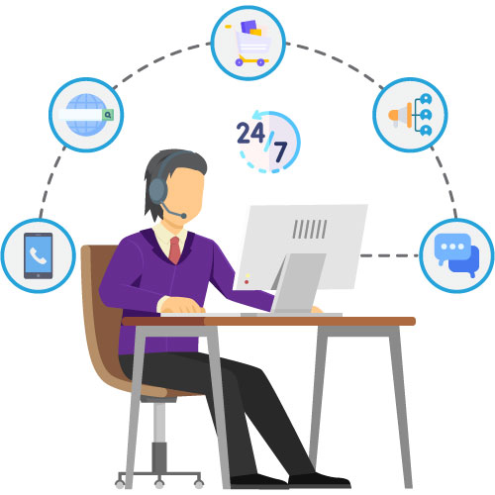

Today, people carry out research, consideration, and purchase across multiple channels. So, they expect seamless across these channels and devices. E-commerce businesses should therefore make themselves omnichannel-ready.  You need to provide customers with the content they want at the time they want, and the place they want it.

So, you need to adopt some of the latest technologies that perform well in an interconnected buyer or user journeyto tap into the *scope of e-commerce*. Some of these include-

* Video Chat that lets your brand converse face-to-face with customers.
* Co-browsing- a visual engagement system that simultaneously brings together your customers and agents on the same page so that the agents can smoothly guide them through complicated procedures.
* Screen Sharing- an interactive technique where your customers can share their screen with your agents so that their issues with completing transactions, filling forms, etc. can be resolved.
* Document Interaction- a platform where your agents can safely and securely interact with your customers’ documents.

**TEAM MEMBERS:-**

1. **KADAGALLA SHANKAR**
2. **GUDALA KALYAN KUMAR**
3. **KUNDALA MOHAN**
4. **CHANDKA PAVAN KALYAN**
5. **GOKAVARAPU SNEHIT**